**Health and Social Care Locality Plan**

DRAFT

**Buckie Locality Plan**

**Buckie, Cullen & Fochabers Communities**

Draft 2023/26



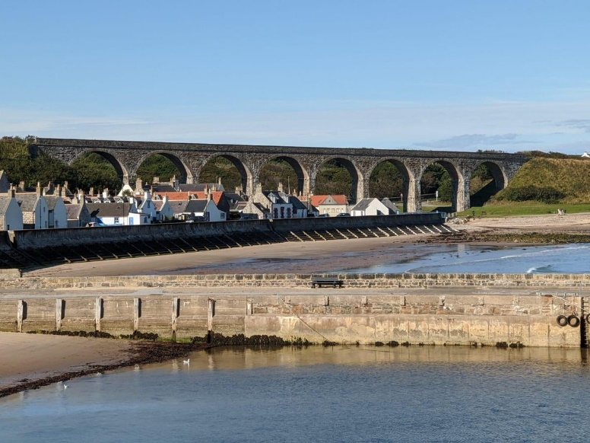

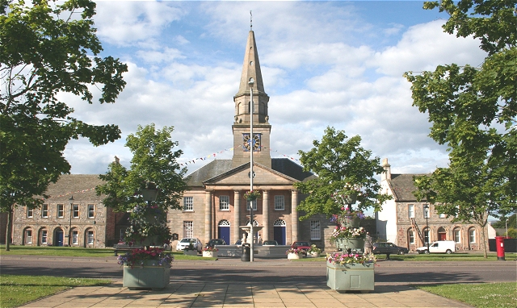

1

# CONTENTS

|  |  |  |
| --- | --- | --- |
|  | **Foreword** | **3** |
| **1** | **INTRODUCTION** | **4** |
| 1.1 | What is a locality? |  |
| 1.2 | What is locality planning? |  |
| 1.3 | Who is the locality plan for? |  |
| 1.4 | What is included in the locality plan? |  |
| 1.5 | The benefits of locality planning |  |
| 1.6 | The wider picture |  |
| 1.7 | What are we hoping to achieve? |  |
| 1.8 | What are the main challenges? |  |
| 1.9 | Locality planning in Buckie, Cullen and Fochabers |  |
| 1.10 | The relationship with other locality initiatives |  |
| 1.11 | What people in Moray are telling us? |  |
| **2** | **ABOUT THE LOCALITY** | **9** |
| 2.1 | Geography |  |
| 2,2 | Population |  |
| 2.3 | Health and Social Care assets |  |
| 2.4 | Health and Social Care challenges |  |
| 2.5 | What are the people living and working in Buckie, Cullen and Fochabers telling us? |  |
| **3** | **PEOPLE AND FINANCES** | **13** |
| 3.1 | People |  |
| 3.2 | Finances |  |
| **4** | **WHAT DO WE NEED TO DO?** | **15** |
| 4.1 | Our local priorities |  |
| **5** | **ACTION PLAN** | **16** |
| **6** | **HOW WILL WE KNOW WE ARE GETTING THERE?** | **21** |
| 6.1 | Measuring performance |  |
| 6.2 | Reference documents |  |

**FOREWORD**



I am delighted to present this 2023/2026 Locality Plan. The actions outlined within this plan support the overarching Strategic Plan for Health and Social Care in Moray, which was widely consulted on with many stakeholders, including citizens, patients and service users.

Each of the four local areas (Elgin; Forres and Lossiemouth; Keith and Speyside; and Buckie, Cullen and Fochabers) that make up the Health and Social Care Moray Partnership have developed their own specific Locality Plan with partners, including patients, service users, carers, the third and independent sectors. Within the Buckie Locality Plan we have included actions and areas for improvement which are also being implemented on a region wide basis, and highlighted those more specific to Buckie, Cullen and Fochabers.

Locality Plans will be updated annually to show how the Strategic Plan is being implemented locally.

This Plan captures some of the ways that the Buckie Locality will work to deliver on the strategic priorities over the next three years. This is far from an exhaustive list, but represents some of the most significant pieces of work being taken forward across Buckie Locality during the lifetime of the Strategic Plan. There is a particular emphasis on equality of access and service provision, community engagement, partnership working and also in using information and data to support improvement.

The Health and Care Partnership believe that the region’s people can flourish, with access to health and social care support when they need it, so it is crucial to ensure that the services delivered reflect the needs of individuals.

Buckie, Cullen and Fochabers Locality is committed to planning and designing services in partnership with local people, working in partnership with residents, staff, independent contractors and also our key partners across primary care, secondary care, health and social care, care homes, housing and the third sector providers.

I look forward to seeing the delivery of the plan which will support the provision of high quality health and social care services for the people of Buckie, Cullen and Fochabers Locality.



Simon Bokor-Ingram

Chief Officer, Health and Social Care Moray

# INTRODUCTION

## 1.1. What is a locality?

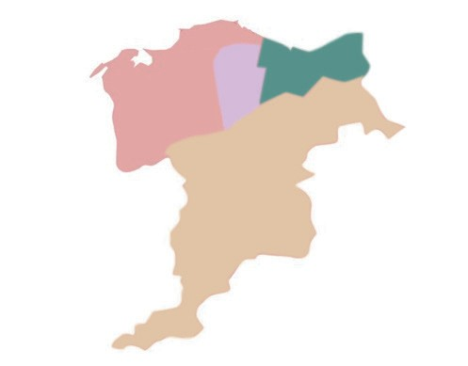A locality is described as a small area within the Integration Authority. They are not defined by hard borders but instead represent natural communities. Localities are expressed

by geography, the people that live and work in the area, the characteristics of the population and to some extent by existing services such as the location of community hospitals, health centres, schools and social work offices.

Moray has four localities and is supported by four Locality Managers:

* + Elgin, Lesley Attridge
  + Forres and Lossiemouth, Iain Macdonald
  + Speyside and Keith, Cheryl St Hilaire
  + Buckie, Cullen and Fochabers, Laura Sutherland
  1. **What is Locality Planning**

Locality planning empowers residents and those working in a locality to play an active role in identifying the priorities for health and social care in each of those localities and to shape the delivery of services for the future. It shows how the strategic objectives of Health and Social Care Moray (HSCM) will be delivered at a community level, acknowledging the unique wants and needs of those in each locality.

* 1. **Who is the Locality Plan for?**

This plan is for people living in the Buckie, Cullen and Fochabers Locality area of Moray who currently have access to health and social care services and also for those who may require care and support in the future. Furthermore, it is aimed at people who are well and want to maintain or improve their health and wellbeing.

* 1. **What is included in the Locality Plan?**

A locality plan explains how health and social care services will be delivered across each locality based on the wants and needs of those livings and working in it. It identifies how the strategic objectives of Health and Social Care Moray, as well as the nine Health and Wellbeing indicators as established by Scottish Government, will be met. Locality Plans identify local priorities and describe how these will be met through an action plan.

## The benefits of locality planning

* + - Each locality has the opportunity to play an active role in service design and improvement.
    - The process will increase awareness of current services and celebrate successful partnership working.
    - Identify and ensure that the needs of the locality are being addressed by those who know it best.
    - Create a culture where these developing relationships can lead to real change and encourages multi-disciplinary team working.

## The wider picture

This plan will be one of a number plans for Health and Social Care Moray and will align with our wider strategic priorities as well as the nine national health and wellbeing outcomes.

The strategic plan sets out our high level priorities which provide direction for the Partnership. The commissioning strategy ensures funding is aligned to the projects that are linked to the strategic priorities. Locality planning will in turn help inform future commissioning priorities.

The National Health and Wellbeing Outcomes provide a strategic framework for the planning and delivery of health and social care services. The suite of nine National Health and Wellbeing Outcomes focus on improving the experience and quality of services for people using integrated health and social care services, carers and their families. These outcomes focus on improving how services are provided, as well as, the difference that integrated health and social care services should make, for individuals.

## Health and Social Care Moray Themes

**Theme 1: Building Resilience**

Taking greater responsibility for our health and wellbeing.

**Theme 2: Home First**

Being supported at home or in a homely setting as far as possible.

**Theme 3: Partners in Care**

Making choices and taking control over decisions affecting our care and support

* 1. **What are we hoping to achieve?**

The plan is centred on the Moray Health and Social Care Vision:

“We come together as equal and valued partners in care to achieve the best health and wellbeing possible for everyone in Moray throughout their lives.”

We want to see a transformed, sustainable health and care system that manage demand for services in order to safeguard the continued delivery of high-quality care,

support and treatment services for those in most need and to get the best value from our limited resource.

Key to this is the strengthening of our partnerships. By working more closely we can make the most of the assets and talents of the people, communities and organisations in Moray. We will encourage one another to consider what we can do for ourselves, what we will need support to achieve, and the areas of health and wellbeing for which we will depend on.

Success will see everyone in Moray building resilience individually and collectively to prevent poor outcomes, enable independence, and for positive life experiences to prevail.

## What are the main challenges?

Locality planning is not just about redesigning health and social care services, it is about changing the perception on the delivery of health and social care and promoting ownership within communities. This change in culture and thinking is unlikely to happen overnight and instead will be an iterative process. Ensuring that people are engaged with the process from the start is key to success.

In addition, the health and social care landscape has changed significantly over the last 3 years. In some instances the COVID-19 pandemic has had a negative effect on the public’s perception of service delivery. Rebuilding these relationships and growing a more resilient delivery will be paramount to the success of health and social care in Moray.

Finally, unpacking existing practice and processes across Health and Social Care Moray will take time. Historic team structures and models of delivery will need to be evaluated to see how they will operate at a locality level – ensuring they do not become cumbersome and overly bureaucratic at the expense of service delivery.

## Locality Planning in Buckie, Cullen and Fochabers

In order to develop the locality plan an Oversight Group will be established to cover the Buckie Locality. Reporting to the Moray Health and Wellbeing Partnership the remit of the Oversight Group is to:

* + - Promote the values and priorities of the strategic plan for Health and Social Care Moray.
    - To share locality health and social care performance and demographic data to help determine locality priorities.
    - Support and empower the community members, and health and social care professionals within the locality to identify and deliver their priorities.
    - To create, review and monitor the locality plan.

The Oversight Group will include a core membership, however can be supplemented by other members, groups and representatives. As such, membership should be considered fluid allowing for it to adapt to the specific needs and priorities of a locality.

|  |  |
| --- | --- |
| **Proposed Locality Oversight Group Membership - Title and Organisation** | |
| Locality Manager, HSCM | Community Council Representatives |
| Senior Charge Nurse | Care at Home Officer, Moray Council |
| GP | Area Forum Representatives |
| GP Practice Managers | Community Organisation Members |
| Social Worker, Moray Council | Community Nursing, NHSG |
| Occupational Therapist, Moray Council | Community Support Unit Officer, Moray Council |
| Occupational Therapist, NHSG | Children’s Services Locality Representatives, Moray Council |
| Physiotherapist, NHSG | Mental Health Service Representative, NHSG |
| Area Public Health Co-ordinator | Housing Officer, Moray Council |
| Third Sector Representation | Unpaid Carer Representation |
|  |  |
|  |  |

## The relationship with other locality initiatives

Health and Social Care Moray Locality Plans do not operate in isolation and should be considered alongside the various other locality initiatives in Moray, particularly Children and Young Families locality planning and the Local Outcome Improvement Plans. Effort has been put in to ensure there is no duplication of effort, and HSCM is working closely with partners to combine resources and share thinking where possible.

The locality plans should also align the Primary Care Improvement Plan (PCIP)

PCIP outlines how our primary care services will change and is being developed in the context of wider transformation and redesign of services across Moray including the development of effective primary care multi-disciplinary working.

As detailed in the Memorandum of understanding 6 workstream areas are operational across Moray and these continue to be developed to ensure each stream fits with patient and practice needs in the locality.

* Vaccination Transformation Programme
* Pharmacotherapy services
* Community Treatment and Care Services
* Urgent Care (advanced practitioners)
* Additional Professional roles
* Health and Wellbeing Workers

From 2022 - the focus has been primary on Vaccination Transformation Programme; Pharmacotherapy and CTAC.

Work continues to be developed on all 6 and in collaboration with HSCM, NHS Grampian, Moray GP Practices and GP Sub - Committee.

## What people in Moray are telling us?

Engagement and participation with those who live and work in Moray is essential to developing a good understanding of health and wellbeing priorities in the locality and what challenges and opportunities there are. Whilst engagement has been carried out on specific health and social care issues in Moray, thinking about how people living and working in each of the localities are purposefully able to participate and help to develop local plans, is at an early stage. The action plan reflects the need to dedicate more time and resources, to ensure ongoing meaningful engagement with all of the communities within Moray, building on the good work done so far.

# ABOUT THE LOCALITY

This section highlights key information about the Buckie Locality Profile; which encompasses Buckie, Cullen and Fochabers communities profile data which was developed by Health Intelligence Services as an information resource for the development of the locality plans. The full profiles are available on the HSCM website.

## Geography

The Buckie Locality for the purposes of this plan includes, Buckie, Cullen and Fochabers

communities. Many of the areas retain a village feel about them and a strong sense of identity.

## Population

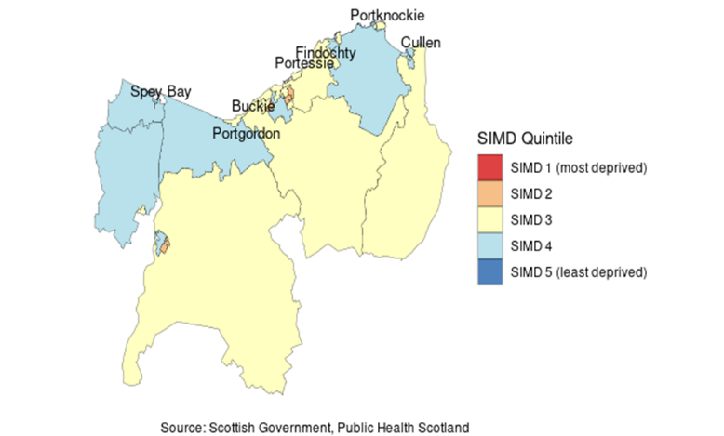The Buckie Locality has a population of 19,898 (as at the latest 2020 census) making it the third largest of the four localities in Moray. It has a roughly equal gender ratio of male to female, with the average life expectancy of males being 79.3 years and females 82.4 years; which is above the Moray and National average. It has the highest percentage of population over 65 years at 25%.

Of the population in the Buckie locality, 0% live in the most deprived Scottish Index of Multiple Deprivation (SIMD) Quintile and 0% live in the least deprived SIMD Quintile. The SIMD ranks all datazones in Scotland by several factors, including; Access, Crime, Education, Employment, Health, Housing and Income. The map opposite shows the datazones within the Buckie Locality coloured by SIMD Quintile. The communities of Cullen and Fochabers are above the Moray and National average for people living in 15% most accessed deprived areas.

## Health and Social Care Assets

The Health and Social Care Partnership Resources in the Buckie Locality are:

|  |  |  |
| --- | --- | --- |
| **Service Type** | **Service** | **Number** |
| Primary Care | GP Practices | 3 |
| Community Hospital | Seafield Hospital | 1 |
| Provider Services | Community Response Team | 1 |
| Residential Care Homes | Elderly Care/Care Homes | 3 |
|  | Other | 1 |

Buckie, Cullen and Fochabers and the surrounding coastal villages also share many core services with Elgin Locality; including Dr Grays Hospital, the only medical hospital in Moray.

## Health and Social Care Challenges

The Buckie, Cullen and Fochabers communities are quite diverse. There are strengths and challenges that are reflected across the whole locality and there are also examples of health inequalities that relate only to a small part of each locality.

The locality has higher than average life expectancy rates in comparison to the Moray or National average, and a higher than average percentage of the population with a long-term (LTC) health condition. In the financial year 2020/21 in the Buckie Locality 24% of the total population had at least one physical long-term condition. Among those who have a two or more LTC’s (multimorbidity) 22% of those are under the age of 65, compared to 54% of those aged over 65. The five most common long term life conditions in order of prevalence are: Asthma, Arthritis, Coronary Heart Disease, Cancer and Diabetes. All are above the Moray and National average, apart from Asthma which is slightly below the Moray average, but above the National average.

The locality records lower than average Unscheduled Care Emergency Admissions and Unscheduled Care Bed days than the Moray or National average. The locality also records the numbers of preventable hospital admissions are equal to the Moray average and slightly lower to the National average.

The locality is in line with the Moray and National average for Mental Health Emergency Admissions, however emergency admissions in the over 65 year olds are increasing.

The locality reports the lowest number of alcohol related hospital admissions than the Moray average, a 22% decrease overall since 2015/16. However, when broken down into data zones, Buckie Central East is 50% higher than Moray Average and 29 % higher than the National Average for alcohol related hospital admissions.

The locality is higher than the Moray average for those in receipt of Carers Allowance and within the Buckie Central East, Cullen and Fochabers communities above the National average.

Deaths aged 15-44 years in Buckie Central East are 30% Higher National and 36% higher than Moray.

Emergency admissions for falls are lower than the Moray average and continues to decrease slowly since 2015/16.

Road traffic accident causalities rates are above the Moray (21%) and National (41%).

Maternal obesity is above the Moray and National average

Delayed Discharges from hospital tend to fluctuate but average out and are equivalent to other Moray localities. The number of people waiting for Occupational Therapy assessments have decreased over the last 12 months by approximately 45%. Those assessed and waiting for a package of care has remained consistent over the past 12 months and is equivalent to other the localities. Those awaiting a social care assessment is lower than other Moray localities.

The number of hours of unmet need in the community over the past 12 months is lower than other Moray localities. The number of hours for individuals assessed in Hospital for unmet need in the last 12 months reduced dramatically.

Locality data allows us to subdivide the Buckie, Cullen and Fochabers locality into 5 datazones which provides the ability to drill down into specific communities within the locality. Providing the opportunity to either take a locality wide approach or a community specific approach to address health and social care inequalities.

## What are the people living and working in Buckie Locality telling us?

Buckie Central East was chosen as a pilot area for Local Outcome Improvement Planning (LOIP), extensive community consultation was undertaken during 2018/19 and resulted in a Buckie Locality Plan. The area of interest was broadened to include the whole of Buckie, with a review of the Buckie Locality Plan undertaken between November 21 and January 2022.

The people of Buckie Locality are very proud of their communities. There are many assets that promote healthy living in terms of facilities, community spirit, coastal location, parks, forests and a variety of independent shops, services and local cafes.

Through engagement activities the aim is to further engage with the communities of Cullen and Fochabers to help us build on and develop our Buckie Locality Plan.

To date the priorities below have been identified:

* + - Improve access to GPs/appropriate health professionals.
    - Improve Health and Wellbeing (Mental and Physical Health) of all ages
    - Connectivity – transport and digital access

# PEOPLE AND FINANCES

## People

Health and Social Care Teams operate across Moray and aim:

* + - To work collectively as a multi-disciplinary team.
    - Meeting the needs of “people” must be at the core of everything they do.
    - Professionals acknowledge the skills and expertise of others within the team.

The oversight group for the Buckie Locality will work with the local health and social care teams, organisations and communities to review the best use of available resources and how this can be managed to support ongoing work to deliver the strategic priorities within the locality area.

Health and Social Care Moray continue to facilitate discussions with key partners and stakeholders across health and social care; developing workforce plans across our integrated teams. Evidence shows that staff who are valued, treated well and supported to give their best will deliver better outcomes for people. We commit to value our workforce and develop the changes that need to be made to ensure a high quality of service is provided.

This will ensure a healthy organisational culture from a capable workforce who are then able to deliver integrated services, supported through effective leadership and management.

**3.1          Finance**

The 2022/23 budget for Health and Social Care Moray is £172m. Whilst some areas of the budget can be easily separated to a locality level, other areas remain Moray wide. The aim would be to divide further aspects of the budget out to localities as progress is made in the coming years. This will allow budgets to work at a more localised level better supporting the community and the people who live within that locality requiring support from H&SCM. The budget for 2023/24 is yet to be set.

# WHAT DO WE NEED TO DO?

## Our Local Priorities

The Buckie Locality has yet to establish an Oversight Group, the aim is have this established by the end of April 2023.

The Oversight Group will build on the key priorities identified to date and ensure they support the nine health and wellbeing outcomes set by the Scottish Government and our Health and Social Care Moray strategic themes.

Priorities identified to date

* + - To develop models for engaging with the community; ensuring the communities voice is visible within locality planning and strategic planning processes.
    - To improve access to appropriate health and social care services
    - To improve Health and Wellbeing (Mental and Physical Health) of all ages
    - To improve Multi-disciplinary Team working.
    - To improve connectivity - transport and digital access

# ACTION PLAN

|  |  |  |  |  |
| --- | --- | --- | --- | --- |
| **Local Priority 1** | | | | |
| Establishing Buckie Locality Oversight Group with Terms of Reference | | | | |
| **Action** | **Measure of Success** | **Desired Outcome** | **Timeline** | **Progress**  **%** |
| Identify and Engage with members to establish the Oversight Group |  | To have a shared responsibility to respond to identified priorities to improve outcomes for the Buckie, Cullen and Fochabers Communities. |  |  |
| Schedule a series of Oversight Group Meetings |  |  |  |  |
| Disseminate the draft Buckie Locality Plan to the Oversight Group |  |  |  |  |

|  |  |  |  |  |
| --- | --- | --- | --- | --- |
| **Local Priority 2** | | | | |
| Establish models of engaging with the community and ensuring the communities’ voice is visible within locally planning and strategic planning processes; building on and extending the reach of community engagement undertaken as part of the Local Outcome Improvement Plan (LOIP). | | | | |
| **Action** | **Measure of Success** | **Desired Outcome** | **Timeline** | **Progress**  **%** |
| Plan a community engagement event for the Buckie Locality which promotes positive messaging, gathers views of public and other stakeholders, and contributes towards locality planning and HSCM Strategic Plan |  | To identify community priorities |  |  |

|  |  |  |  |  |
| --- | --- | --- | --- | --- |
| **Local Priority 3** | | | | |
| To improve Health and Wellbeing (Mental and Physical Health) of all ages | | | | |
| **Action** | **Measure of Success** | **Desired Outcome** | **Timeline** | **Progress**  **%** |
| Identify gaps within current range of services available within communities |  |  |  |  |
| Social Prescribing - Develop a model of provision encompassing a range of services available within communities |  |  |  |  |
| Review preventative approaches to address the 5 most prevalent Long Term Conditions: Asthma, Arthritis, Coronary Heart Disease, Cancer and Diabetes |  |  |  |  |
| Maximise opportunities for all via preventive approaches/conversations through the use of Making Every Opportunity Count tools/training |  |  |  |  |

|  |  |  |  |  |
| --- | --- | --- | --- | --- |
| **Local Priority 4** | | | | |
| To improve Multi-Disciplinary Team (MDT) working. | | | | |
| **Action** | **Measure of Success** | **Desired Outcome** | **Timeline** | **Progress**  **%** |
| Identify and review the MDT model within the Buckie Locality |  | Improvement in Multi Disciplinary Team working within Buckie Locality | Jun –  2023 |  |
| Evaluate 'How Good Is Our MDT Working' within Buckie Locality |  |  | Sept –  2023 |  |
| Implement improvements identified |  |  |  |  |

|  |  |  |  |  |
| --- | --- | --- | --- | --- |
| **Local Priority 5** | | | | |
| Support access to appropriate Health and Social Care services. | | | | |
| **Action** | **Measure of Success** | **Desired Outcome** | **Timeline** | **Progress**  **%** |
| Review public information regarding contacting local GP, and Health and Social Care professionals. |  | Increase in public satisfaction |  |  |
| Promote and inform the public in regards to the current models of practice. |  |  |  |  |
| Support individuals within localities to access health care support through digital technology. |  | Improve access to health and social care services via the use of digital technology |  |  |
| Research, and equip specific sites within the locality to house digital technology to access health and social care professionals. |  |  |  |  |

|  |  |  |  |  |
| --- | --- | --- | --- | --- |
| **Local Priority 6** | | | | |
| To improve connectivity – Transport and Connectivity | | | | |
| **Action** | **Measure of Success** | **Desired Outcome** | **Timeline** | **Progress**  **%** |
|  |  |  |  |  |

**HOW WILL WE KNOW WE ARE GETTING THERE?**

## Measuring Performance

The targets within the Locality Action Plan will be reviewed by Locality Oversight Group on a bimonthly basis, with a more in depth review against locality performance and demographic data on an annual basis.

Regular reports from the Locality Oversight Group to the HSCM Senior Leadership Team and the Moray Integration Joint Board will help demonstrate what outcome integrating services is having for the people who access the services and support. A performance report will be developed each year as required by legislation.

## Reference Documents

* + - Health and Social Care Moray Strategic Plan 2019 - 2029
    - Health and Social Care Standards 2015
    - National Health and Wellbeing Outcomes 2017
    - Public Health Scotland Strategic Plan 2020 – 2023
    - Scottish Public Health Observatory Profile Data for Buckie, Cullen and Fochabers Areas
    - NHSG Locality Profile Data
    - NHSG Health and Wellbeing Profiles
    - HSCM Daily Performance Data
    - Buckie Locality Action Plan 2019 – 2029 ‘A Better Buckie’

19



**Health and Social Care Moray are committed to meaningful and sustained engagement with all stakeholders.**

**If you would like to be added to our locality communications group please contact us and we will send you an application form. We will keep you up to date with opportunities to work with**

**us and use your knowledge, skills and live in experience to help achieve positive change.**

