

**Health and Social Care Locality Plan**

DRAFT

**Keith & Speyside**

Draft 2023/26

DRAFT



1

# CONTENTS

|  |  |  |
| --- | --- | --- |
|  | **Foreword** | **3** |
| **1** | **INTRODUCTION** | **4** |
| 1.1 | What is a locality? |  |
| 1.2 | What is locality planning? |  |
| 1.3 | Who is the locality plan for? |  |
| 1.4 | What is included in the locality plan? |  |
| 1.5 | The benefits of locality planning |  |
| 1.6 | The wider picture |  |
| 1.7 | What are we hoping to achieve? |  |
| 1.8 | What are the main challenges? |  |
| 1.9 | Locality planning in Keith and Speyside |  |
| 1.10 | The relationship with other locality initiatives |  |
| 1.11 | What people in Moray are telling us? |  |
| **2** | **ABOUT THE LOCALITY** | **9** |
| 2.1 | Geography |  |
| 2,2 | Population |  |
| 2.3 | Health and Social Care assets |  |
| 2.4 | Health and Social Care challenges |  |
| 2.5 | What are the people living and working in Keith and Speyside telling us? |  |
| **3** | **PEOPLE AND FINANCES** | **13** |
| 3.1 | People |  |
| 3.2 | Finances |  |
| **4** | **WHAT DO WE NEED TO DO?** | **15** |
| 4.1 | Our local priorities |  |
| **5** | **ACTION PLAN** | **16** |
| **6** | **HOW WILL WE KNOW WE ARE GETTING THERE?** | **19** |
| 6.1 | Measuring performance |  |
| 6.2 | Reference documents |  |

**FOREWORD**

I am delighted to present this 2023/2025 Locality Plan. The actions outlined within this plan support the overarching Strategic Plan for Health and Social Care in Moray, which was widely consulted on with many stakeholders, including citizens, patients and service users.

Each of the four local areas (Elgin; Forres and Lossiemouth; Keith and Speyside; and Buckie and Cullen) that make up the Health and Social Care Moray Partnership have developed their own specific Locality Plan with partners, including patients, service users, carers, the third and independent sectors. Within the Keith and Speyside Locality Plan we have included actions and areas for improvement which are also being implemented on a region wide basis, and highlighted those more specific to Keith and Speyside.

Locality Plans will be updated annually to show how the Strategic Plan is being implemented locally.

This Plan captures some of the ways that the Keith and Speyside Locality will work to deliver on the strategic priorities over the next three years. This is far from an exhaustive list, but represents some of the most significant pieces of work being taken forward across Keith and Speyside Locality during the lifetime of the Strategic Plan. There is a particular emphasis on equality of access and service provision, community engagement, partnership working and also in using information and data to support improvement.

The Health and Care Partnership believe that the region’s people can flourish, with access to health and social care support when they need it, so it is crucial to ensure that the services delivered reflect the needs of individuals.

Keith and Speyside Locality is committed to planning and designing services in partnership with local people, working in partnership with residents, staff, independent contractors and also our key partners across primary care, secondary care, health and social care, care homes, housing and the third sector providers.

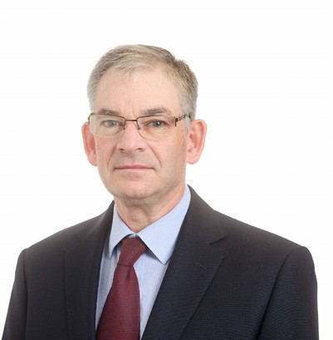I look forward to seeing the delivery of the plan which will support the provision of high quality health and social care services for the people of Keith and Speyside locality.

Simon Bokor-Ingram

Chief Officer, Health and Social Care Moray

# INTRODUCTION

## 1.1. What is a locality?

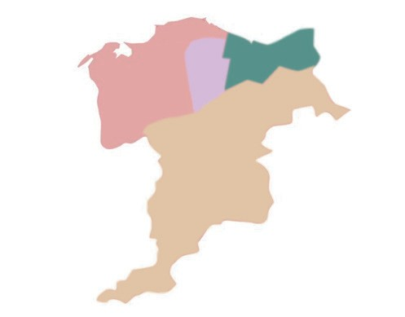A locality is described as a small area within the Integration Authority. They are not defined by hard borders but instead represent natural communities. Localities are expressed

by geography, the people that live and work in the area, the characteristics of the population and to some extent by existing services such as the location of community hospitals, health centres, schools and social work offices.

Moray has four localities and is supported by four Locality Managers:

* + Elgin, Lesley Attridge
  + Forres and Lossiemouth, Iain Macdonald
  + Speyside and Keith, Cheryl St Hilaire
  + Buckie, Cullen and Fochabers, Laura Sutherland
  1. **What is Locality Planning**

Locality planning empowers residents and those working in a locality to play an active role in identifying the priorities for health and social care in each of those localities and to shape the delivery of services for the future. It shows how the strategic objectives of Health and Social Care Moray (HSCM) will be delivered at a community level, acknowledging the unique wants and needs of those in each locality.

* 1. **Who is the Locality Plan for?**

This plan is for people living in the Keith and Speyside area of Moray who currently have access to health and social care services and also for those who may require care and support in the future. Furthermore, it is aimed at people who are well and want to maintain or improve their health and wellbeing.

* 1. **What is included in the Locality Plan?**

A locality plan explains how health and social care services will be delivered across each locality based on the wants and needs of those livings and working in it. It identifies how the strategic objectives of Health and Social Care Moray, as well as the nine Health and Wellbeing indicators as established by Scottish Government, will be met. Locality Plans identify local priorities and describe how these will be met through an action plan.

## The benefits of locality planning

* + - Each locality has the opportunity to play an active role in service design and improvement.
    - The process will increase awareness of current services and celebrate successful partnership working.
    - Identify and ensure that the needs of the locality are being addressed by those who know it best.
    - Create a culture where these developing relationships can lead to real change and encourages multi-disciplinary team working.

## The wider picture

This plan will be one of a number plans for Health and Social Care Moray and will align with our wider strategic priorities as well as the nine national health and wellbeing outcomes.

The strategic plan sets out our high level priorities which provide direction for the Partnership. The commissioning strategy ensures funding is aligned to the projects that are linked to the strategic priorities. Locality planning will in turn help inform future commissioning priorities.

The national health and wellbeing outcomes provide a strategic framework for the planning and delivery of health and social care services. The suite of nine national health and wellbeing outcomes focus on improving the experience and quality of services for people using integrated health and social care services, carers and their families. These outcomes focus on improving how services are provided, as well as, the difference that integrated health and social care services should make, for individuals.

## Health and Social Care Moray Themes

**Theme 1: Building Resilience**

Taking greater responsibility for our health and wellbeing.

**Theme 2: Home First**

Being supported at home or in a homely setting as far as possible.

**Theme 3: Partners in Care**

Making choices and taking control over decisions affecting our care and support

* 1. **What are we hoping to achieve?**

The plan is centered on the Moray Health and Social Care Vision:

“We come together as equal and valued partners in care to achieve the best health and wellbeing possible for everyone in Moray throughout their lives.”

We want to see a transformed, sustainable health and care system that manage demand for services in order to safeguard the continued delivery of high-quality care,

support and treatment services for those in most need and to get the best value from our limited resource.

Key to this is the strengthening of our partnerships. By working more closely we can make the most of the assets and talents of the people, communities and organisations in Moray. We will encourage one another to consider what we can do for ourselves, what we will need support to achieve, and the areas of health and wellbeing for which we will depend on.

Success will see everyone in Moray building resilience individually and collectively to prevent poor outcomes, enable independence, and for positive life experiences to prevail.

## What are the main challenges?

Locality planning is not just about redesigning health and social care services, it is about changing the perception on the delivery of health and social care and promoting ownership within communities. This change in culture and thinking is unlikely to happen overnight and instead will be an iterative process. Ensuring that people are engaged with the process from the start is key to success.

In addition, the health and social care landscape has changed significantly over the last 3 years. In some instances the COVID-19 pandemic has had a negative effect on the public’s perception of service delivery. Rebuilding these relationships and growing a more resilient delivery will be paramount to the success of health and social care in Moray.

Finally, unpacking existing practice and processes across Health and Social Care Moray will take time. Historic team structures and models of delivery will need to be evaluated to see how they will operate at a locality level – ensuring they do not become cumbersome and overly bureaucratic at the expense of service delivery.

## Locality Planning in Keith and Speyside

In order to develop the locality plan an Oversight Group is being established to cover the Keith and Speyside area. Reporting to the Moray Health and Wellbeing Partnership the remit of the Oversight Group will be to:

* + - Promote the values and priorities of the strategic plan for Health and Social Care Moray.
    - To share locality health and social care performance and demographic data to help determine locality priorities.
    - Support and empower the community members, and health and social care professionals within the locality to identify and deliver their priorities.
    - To create, review and monitor the locality plan.

The Oversight Group includes a core membership, however can be supplemented by other members, groups and representatives. As such, membership should be considered fluid allowing for it to adapt to the specific needs and priorities of a locality.

The list below is not exhaustive, but does give an overview of just some of the representation that would support the Oversight Group dependent on need.

|  |  |
| --- | --- |
| **Locality Oversight Group Membership – Core and other representation** | |
| Locality Manager, HSCM | Community Council Representatives |
| GP | Carer Representation |
| GP Practice Manager | Community Organisation Members |
| Social Worker, Moray Council | Community Nursing, NHSG |
| Occupational Therapist, Moray Council | Community Support Unit Officer, Moray Council |
| Occupational Therapist, NHSG | Children’s Services Locality Representatives, Moray Council |
| Physiotherapist, NHSG | Mental Health Service Representative, NHSG |
| Care at Home Officer, Moray Council | National and Local Third Sector |
| HSCM Health Improvement Team | Specialist Clinicians |
| Area Forum Representative | HSCM Volunteer Services |
| Housing Officer, Moray Council | Local Businesses |
| Senior Charge Nurse (SCN) | KELP Representative |

## The relationship with other locality initiatives

Health and Social Care Moray Locality Plans do not operate in isolation and should be considered alongside the various other locality initiatives in Moray, particularly Children Service Planning, and the work of the Moray Council Communities Team and Local Outcome Improvement Plans. Members of these group will be invited to attend the Keith and Speyside Oversight Group to ensure there is no duplication of effort, and HSCM is working closely with partners to combine resources and align planning activity where possible.

The locality plans should also align the Primary Care Improvement Plan (PCIP)

PCIP outlines how our primary care services will change and is being developed in the context of wider transformation and redesign of services across Moray including the development of effective primary care multi-disciplinary working.

As detailed in the Memorandum of understanding 6 workstream areas are operational across Moray and these continue to be developed to ensure each stream fits with patient and practice needs in the locality.

* Vaccination Transformation Programme
* Pharmacotherapy services
* Community Treatment and Care Services
* Urgent Care (advanced practitioners)
* Additional Professional roles
* Health and Wellbeing Workers

From 2022 - the focus has been primary on Vaccination Transformation Programme; Pharmacotherapy and CTAC.

Work continues to be developed on all 6 and in collaboration with HSCM, NHS Grampian, Moray GP Practices and GP Sub - Committee.

## What people in Moray are telling us?

Engagement and participation with those who live and work in Moray is essential to developing a good understanding of health and wellbeing priorities in the locality and what challenges and opportunities there are. Whilst engagement has been carried out on specific health and social care issues in Moray, thinking about how people living and working in each of the localities are purposefully able to participate and help to develop local plans, is at an early stage. The action plan reflects the need to dedicate more time and resources, to ensure ongoing meaningful engagement with all of the communities within Moray, building on the good work done so far.

# ABOUT THE LOCALITY

This section highlights key information about the Keith and Speyside Locality taken from the Keith and Speyside Locality Profile which was developed by Health Intelligence Services as an information resource for the development of the locality plans. The full profiles are available on the HSCM website.

## Geography

The Keith and Speyside locality covers a vast geography and includes a mix of large and smaller settlements including Keith, Aberlour, Dufftown, Craigallachie, Rothes, Tomintoul, Glenlivet and Archiestown. Many of the areas retain a village feel about them and a strong sense of identity.

The locality also shares its borders with Highland Council and Aberdeenshire Council.

## Population

The Keith and Speyside locality is vast and has a population of 15,380 (at the latest 2020 census) making it the smallest of the four localities in Moray with regards the population, but the largest with regards geographical spread. It is home to 4 GP practices and 3 care facilities.

The Keith and Speyside locality, as mentioned above, has a population of 15,380 (as at the latest 2020 census). It has a roughly equal gender ratio of male to female at 1:0.96 with the average life expectancy of males being 79.8 years and females 83.1 years.

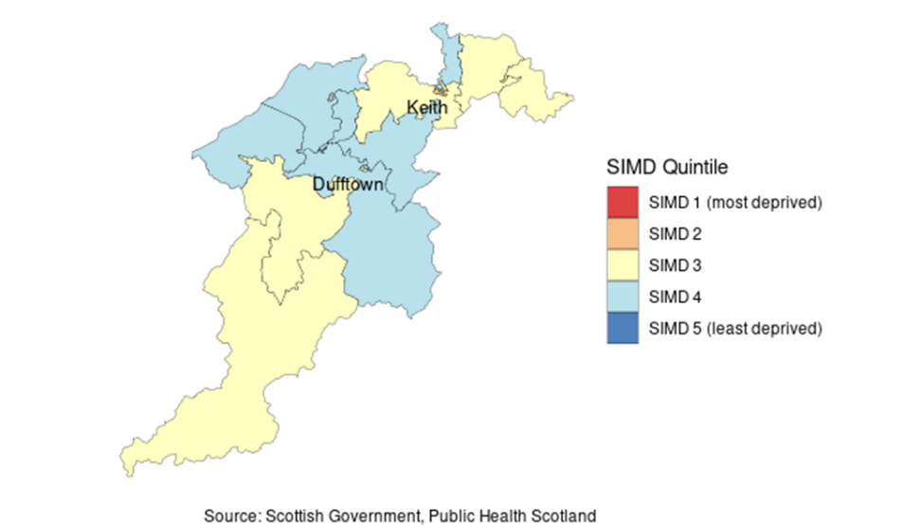For the most recent time periods available, Keith and Speyside Locality had:

* A total population of 15,380 people, where 49% were male, and 25% were aged over 65.
* 0% of people lived in the least deprived SIMD quintile, and 0% lived in the most deprived quintile.

The Scottish Index of Multiple Deprivation (SIMD) ranks all data zones in Scotland by several factors , including Access, Crime, Education, Employment, Health, Housing and Income.

## Health and Social Care Assets

The Health and Social Care Resources in the Keith and Speyside Locality include:

|  |  |  |
| --- | --- | --- |
| **Service Type** | **Service** | **Number** |
| Primary Care | GP Practices | 4 |
|  | Services and Treatment Hub | 1 |
|  | 2 District Nurse Team | 2 |
|  | Community Response Team | 1 |
| A&E | Emergency Departments | 0 |
|  | Minor Injury Units | 0 |
| Social Care | Care Homes | 3 |
|  | Sheltered / Very Sheltered Housing | 1 |
|  | Social Work Team | 1 |

The Keith and Speyside Locality is also in close proximity to Dr Gray’s Hospital, the only acute hospital in Moray.

## Health and Social Care Challenges

The Keith and Speyside communities are quite diverse. There are strengths and challenges that are reflected across the whole locality and there are also examples of health inequalities that relate only to a small part of each locality.

The locality has higher than average life expectancy rates in comparison to the Moray or National average, and higher average percentage of the population with a long term health condition in comparison to Moray and the rest of Scotland. The five most common long term life conditions in order of prevalence are: Asthma, Arthritis, Cancer, Coronary Heart Disease and Diabetes.

The locality records Unscheduled Care Emergency Admissions but a higher unscheduled Care Bed days in line with the rest of Moray and lower than the National average. The locality also records lower numbers of preventable hospital admissions than the Moray or National average.

The Keith and Speyside locality has a high percentage of the population aged 65+ in comparison with the rest of Moray and Scotland.

The locality records lower than average Mental Health Emergency Admissions than the Moray or National average, however has a higher than average use of unscheduled bed days (particularly for the 18 to 44yr old category), and also records higher readmissions than the Moray average.

The locality reports a higher number of alcohol related hospital admissions than the Moray average.

Overall people reporting falls are lower than the Moray average.

Locality data allows us to subdivide the Keith and Speyside Locality into different data zones which provides the ability to drill down into specific communities within the locality. Providing the opportunity to either take a locality wide approach or a community specific approach to address health and social care inequalities.

## What are the people living and working in Keith and Speyside telling us?

Through our staff teams and other partners working across Keith and Speyside and by utilising statistical and national data, we have been able to identify some of the common themes and area we would like to address. Key priorities will be identified through our Oversight Group.

Planned events in the Keith and the Speyside areas ‘Let’s talk Health, Wellbeing and Communities’ will provide us with a greater understanding by giving local communities the opportunity to feedback to us about what matters to them and to also meet and talk to a variety of services to raise awareness and support self-resilience and prevention. These events will also offer a networking and awareness opportunity for health and social care teams and the third sector, alongside collaborative working opportunities.

We recognise that not everyone will be able to/want to attend an event so we will ensure that these people are given the opportunity to engage through a variety of methods including QR codes/access to online versions of surveys and questionnaire, paper based versions, through our staff teams and via other representation locally.

The Keith and East Locality Project (KELP) was paused at the beginning of the Covid outbreak, but is now active again with regular meetings, workshops and engagement both in and around the Keith area and with health, social and community representation.

We will further develop our communication vehicles to support engagement and to ensure that the communities in the Keith and Speyside have adequate information to support their expectations and to have the knowledge and support to support their own wellbeing, around prevention and improving their own resilience.

We will continue to work with the services, third sector and community groups in the locality so that we have a lateral overview and are able to work together, taking a holistic approach to support, empower and develop communities and services. This includes specialist groups, service users and third sector organisations such as Carers, Dementia and Arthritis etc.

To date, and listening to what our communities and partners are saying, we have been successful in encouraging several services into the locality by offering working space in the Fleming Services Hub, which include substance misuse support, Arthritis support and a toe nail clipping service to support better foot health and falls prevention.

Working collaboratively has also allowed us to introduce ‘free’ and charged first aid course in the Speyside area, again to support resilience.

Some of the services and professionals utilising the Fleming Services Hub include District Nurses, Care at Home, Community Response team (CRT), Podiatry, Occupational therapy, Physio therapy, Health improvement team (weekly health point), Health Visitor classes, Blood Clinics, Immunisations, Renal screening, rape and sexual abuse support, Social Work, Mental Health and Dementia support. The hub allows services to be delivered closer to home for communities.

COVID has impacted communities across Moray and seen the necessity of many professions to deliver services in different ways. We are also finding ourselves in unprecedented times with staff pressures and a growing ageing population requiring medical and social care support.

Enabling people to stay healthy, build their resilience and avoid preventable accidents and illness is central to supporting resilience moving forward.

Professionals, third sector and community groups being able to work collaboratively with is also vital to ensure we have a good and ‘real time’ lateral overview of the what is happening across communities in order to prevent duplication of effort and make accessing information, support and services streamlined and simple for communities.

Our staff are our eyes and ears on the ground and as such can also be out voice. By ensuring that we keep our teams up to date what is happening across the locality and wider Moray area including new and current services, opportunities and plans, they can be sharing and discussing matters with their patients/clients and feed any relevant information, including suggestions, back into the locality oversight group to provide a greater understanding of what people are saying to support plans and work.

In accordance with the nine health and wellbeing outcomes set by the Scottish Government, our Health and Social Care Moray strategic themes and the various community and staff consultation and engagement events to date, we have identified the following key priorities for 2023 to 2025.

1. Working with and understanding the needs and expectations of local communities
2. Prevention, Awareness, Self-Support and improved access to services and support
3. Further development and growth of multi-disciplinary team working (MDT) to ensure that the right people are around the right matter at the right time

# PEOPLE AND FINANCES

## People

Health and social care teams operate across Moray and aim:

* + - To work collectively as a multi-disciplinary team.
    - Meeting the needs of “people” must be at the core of everything they do.
    - Professionals acknowledge the skills and expertise of others within the team.

The oversight group for Keith and Speyside will work with the local health and social care teams, organisations and communities to review the best use of available resources and how this can be managed to support ongoing work to deliver the strategic priorities within the locality area.

Health and Social Care Moray continue to facilitate discussions with key partners and stakeholders across health and social care; developing workforce plans across our integrated teams. Evidence shows that staff who are valued, treated well and supported to give their best will deliver better outcomes for people. We commit to value our workforce and develop the changes that need to be made to ensure a high quality of service is provided.

This will ensure a healthy organisational culture from a capable workforce who are then able to deliver integrated services, supported through effective leadership and management.

## Finance

The 2022/23 budget for Health and Social Care Moray is £172m. Whilst some areas of the budget can be easily separated to a locality level, other areas remain Moray wide. The aim would be to divide further aspects of the budget out to localities as progress is made in the coming years. This will allow budgets to work at a more localised level better supporting the community and the people who live within that locality requiring support from H&SCM. The budget for 2023/24 is yet to be set.”

# WHAT DO WE NEED TO DO?

## Our Local Priorities

In accordance with the nine health and wellbeing outcomes set by the Scottish Government, our Health and Social Care Moray strategic themes and the various community and staff consultation and engagement events, we have identified the following key priorities for 2023 to 2025.

1. Working with and understanding the needs and expectations of local communities

2. Prevention, Awareness, Self-Support and improved access to services and support

3. Further development and growth of multi-disciplinary team working (MDT) to ensure that the right people are around the right matter at the right time

As the Locality Oversight Group develops and we continue engaging with communities, staff and professionals, we will be able to identify more specific actions and measures that we want to achieve, but all of which will sit under the above 3 priorities.

# ACTION PLAN

|  |  |  |  |  |
| --- | --- | --- | --- | --- |
| **Local Priority 1** | | | | |
| **Working with and understanding the needs and expectations of local communities** | | | | |
| **Action** | **Measure of Success** | **Desired Outcome** | **Timeline** | **Progress**  **%** |
| **Events** - ‘Let’s talk health, wellbeing and communities’ events.  **Keith**  **Speyside** | Turnout of services, groups and public and event feedback. | Networking and familiarization of services and groups working in area. Awareness raising and education of communities and services .Prevention through raising awareness.  Holistic overview of communities needs and expectations to support Locality Planning and collaborative working  Prevent duplication of effort and work across the locality and build on joint working opportunities and alignment of plans.  Being able to utlise existing networks, services and groups to share and obtain information via to support awareness and prevention. | Aug 2022  Sept 2023 | 100%  10% |
| **Surveys** **and Data** – working collaboratively with the Communality Development Unit (CDU) and Health Improvement Team and others as appropriate to gain a holistic overview of the area, needs and expectations of the community.  **Keith**  **Speyside** | Surveys completed and feedback collated  Utilise data available to HSCM, alongside any additional data available via CDU, Health Improvement Team and others to build a holistic overview of the locality. | July – Sept 2022  Aug – Oct 2023 | 75%  10% |
| **Networks and Communication** - Working and talking with other services, third sector and community groups and utilising their community networks, patients and client groups for the sharing and gathering of information. | Collaborative working opportunities and ability to share and obtain information from a variety of client groups across the locality | Jan 2022 - ongoing | 60% |
| **Local Priority 2** | | | | |
| **Prevention, Awareness, Self-Support and improved access to services and support** | | | | |
| **Action** | **Measure of Success** | **Desired Outcome** | **Timeline** | **Progress**  **%** |
| **Development of Oversight Group** | Appropriate representation from across sectors and the community to support Locality Planning and Working | An established Oversight Group with core members and members with specific areas of interest and/or expertise, to plan, support and develop locality planning and work and drive forward key priorities identified. | April 23 - ongoing | 25% |

|  |  |  |  |  |
| --- | --- | --- | --- | --- |
| **Locality Services Hub –** Utilise the Fleming Hospital site to create a services hub. Housing a variety of teams and services | Multiple disciplines delivering services from the hub and preventing communities having to travel to Elgin. Specialist third sector services attracted into the locality | Services delivered nearer to home for Speyside and the wider locality, supporting prevention and living well.  Improved MDT working and opportunities. | March 2022 - ongoing | 60% |
| **KELP** (Keith and East Locality Project) – Determining what is required building wise to deliver GP and other services in the locality | Application to Scottish Government to fund | A custom built building to accommodate a GP practice and other services as determined as needed through various workshops, input and feedback from across services and the community. | Ongoing |  |

|  |  |  |  |  |
| --- | --- | --- | --- | --- |
| **Local Priority 3** | | | | |
| Further development and growth of multi-disciplinary team working (MDT) to ensure that the right people are around the right  matter at the right time | | | | |
| **Action** | **Measure of Success** | **Desired Outcome** | **Timeline** | **Progress**  **%** |

|  |  |  |  |  |
| --- | --- | --- | --- | --- |
| **Professionals Directory –** an online directory with all health and social care professionals working in and across Keith and Speyside Locality. The directory also provides a communication channel for the distribution of news and updates. | People accessing the directory and utilising. | Multi-Disciplinary working opportunities, ensuring the right people are around the appropriate matters at the right time.  Easier and more efficient access for professionals to contact other professionals, with direct contact details and referral processes.  A communication channel to all professionals working in and across the locality. | **Sept 2022** | **100%** |
| **Services Hub –** as detailed in priority 2 |  |  |  |  |
| **Oversight Group –** Development of | An Oversight Group with key partners from across the locality developed to support Locality Plans and working. | A main Oversight Group membership with other disciplines attending to support specific pieces of work and/or communities.  Action plans in place for locality. | **Ongoing 2023** | **30%** |
| **Multi-Disciplinary Working** and **Opportunities** - Document, evaluation and improvement of current models of multi-disciplinary team (MDT) working and meetings across Keith and Speyside | An overview collated of all current MDT working and meetings operating across Keith and Speyside including Community Hospitals  Evaluation of what works well and what could work better, through discussion  Identification of any potential gaps or duplications to MDT working, meetings and opportunities  Discussions and agreement of any improvements, changes and additional MDT working or meetings that might be required. | Efficient and effective MDT working across Keith and Speyside.  MDT meetings relevant and timely.  Prevent duplication of work and improve relationships and understanding across teams.  New opportunities to work collaboratively with other services, third sector and community groups.  Joined up working across locality boundaries to support efficiencies, effectiveness and improve outcomes as appropriate. | March 2023 - ongoing |  |

**HOW WILL WE KNOW WE ARE GETTING THERE?**

## Measuring Performance

The targets within the Locality Action Plan will be reviewed by the appropriate Locality Oversight Group members on a bimonthly basis, with a more in depth review against locality performance and demographic data on an annual basis.

Regular reports from the Locality Oversight Group to the HSCM Senior Leadership Team and the Moray Integration Joint Board will help demonstrate what outcome integrating services is having for the people who access the services and support. A performance report will be developed each year as required by legislation.

## Reference Documents

* + - Health and Social Care Moray Strategic Plan 2019 - 2029
    - Health and Social Care Standards 2015
    - National Health and Wellbeing Outcomes 2017
    - Public Health Scotland Strategic Plan 2020 – 2023
    - Scottish Public Health Observatory Profile Data for Keith and Speyside Areas
    - NHSG Keith and Speyside Locality Profile Data
    - NHSG Health and Wellbeing Profiles
    - HSCM Daily Performance Data
    - HSCM Healthier Lives, Healthier Communities Survey Results
    - Lossiemouth Community Development Trust 5 Year Plan

21



**Health and Social Care Moray are committed to meaningful and sustained engagement with all stakeholders.**

**If you would like to be added to our locality communications group please contact us and we will send you an application form. We will keep you up to date with opportunities to work with**

**us and use your knowledge, skills and live in experience to help achieve positive change.**

